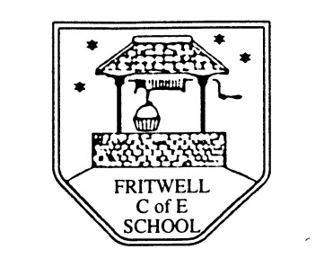
Breakfast Club Booking Form
Each session costs £6 and runs from 7.40 - 8.40am.
Payments will be added to Parent Pay.

Child’s Name: ……………………………………………………………………………………………………………. Date: ……………………….
Summer Term 1 Tuesday 9th Jan to Friday 9th Feb Academic Year 2023-2024
DAY | Week  Beg  8th Jan | Week  Beg  15th Jan | Week  Beg  22nd Jan | Week  Beg  29th Jan | Week  Beg  5th Feb
Monday | X
Tuesday

Wednesday

Thursday

Friday

